1. 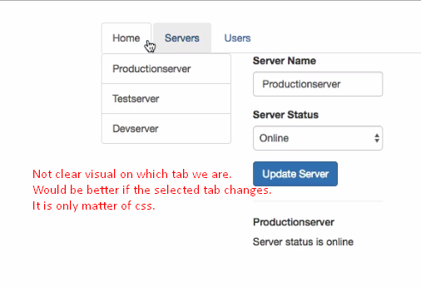   
   This would be really nice if the selected tab would change and that is of course only a CSS thing because if you check your app component here, you will see we get this active class on the list item which determines whether this is **marked as active**. It would be nice if we dynamically set this class.
2. 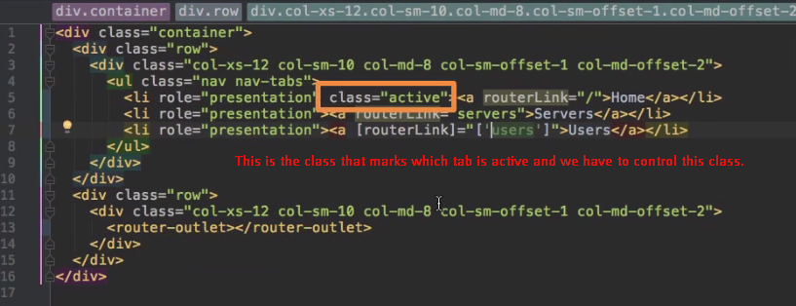
3. **Solution**: **routerLinkActive** directive given by Angular.  
   **NOTE**: It can be added to the <li> or to <a> itself.  
   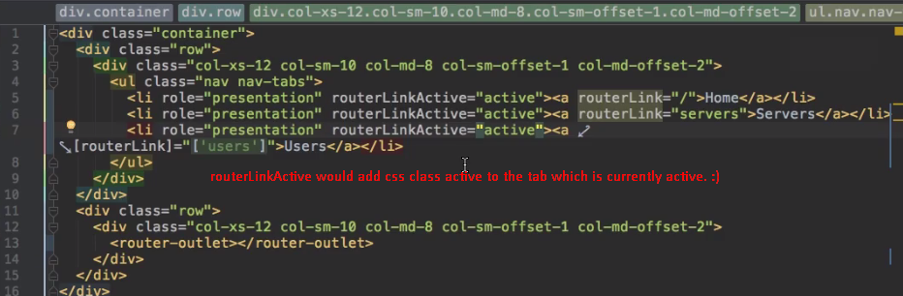  
   **NOTE**: The class inside routerLinkActive can be any css class.
4. 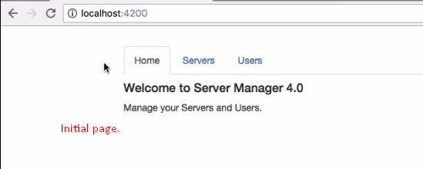
5. **Problem**:  
   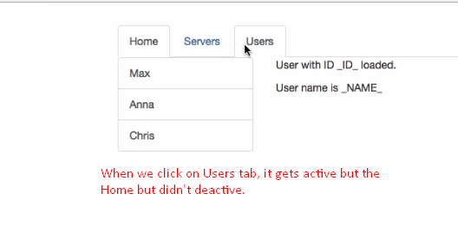  
   Why?  
   **routerLinkActive** directive analyzes your current loaded path and checks whether configured routes is part of the loaded path.   
   Simply, if any configured route matches with the loaded path in the URL, the routerLinkActive adds the specified css class to the tab.
6. 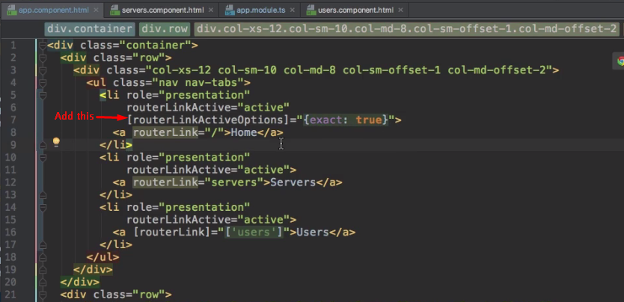  
   To fix this, we can add some configuration to this **routerLinkActive** directive.
7. {exact:true} configuration object: exact is kind of reserved property on this object you passed to routerLinkActiveOoptions and this will now basically tell Angular to add this routerLinkActive class if the exact path matches not just part of path.
8. 